**Almamy Aguibou Bah**

**CMSC 203**

**Assignment 4 Design**

Almamy Aguibou Bah UML Design Document

|  |
| --- |
| Property |
| -property : String  -city : String  -rental amount : double  -owner : String  -plot : Plot |
| //Getters & Setters for fields  //Prints out the name, city, owner and rent amount for a property  +toString : String |

|  |
| --- |
| Plot |
| -x : int  -y : int  -width : int  -depth : int |
| //Determines if this plot overlaps the parameter, return true if the two plots overlap, false otherwise  +overlaps (plot : Plot) : boolean  //takes a Plot instance and determines if the current plot contains it  +encompasses (plot : Plot) : boolean  //take a property and check if it is emcompassed by the plot  //Prints the X,Y of the upper left corner, the width and the depth  +toString : String |

|  |
| --- |
| ManagementCompany |
| -MAX_PROPERTY : int  -mgmFeePer : double  -name : String  -properties : Property []  -taxID : String  -MGMT_WIDTH : int  -MGMT_DEPTH : int  -plot : Plot |
| //Creates a property object and adds it to the "properties" array.  return -1 if the array is full, -2 if the Property object is null, -3 if if management company does not encompass the property plot, -4 if property plot overlaps ANY of properties in array, otherwise return the index of the array where the property was added.  +addProperty (name : String, city : String, rent : double, owner : String, x : int, y : int, width : int, depth : int) : int  //Displays the information of the property at index i  +addProperty( name: String, city: String, rent: double, owner: String): int  +addProperty(property: Property):int  +displayPropertyAtIndex (i : int) : String  //This method finds a property within the properties array that has the maximum rent amount and returns the rent amount.  +maxRentProp : double  // This method finds the index of the property with the maximum rent amount.  +maxRentPropertyIndex : int  //Displays the information of all the properties in the "properties" array.  +toString : String  //This method accesses each "Property" object within the array "properties" and sums up the property rent and returns the total amount.  +totalRent : double |

**Screenshots of program:**

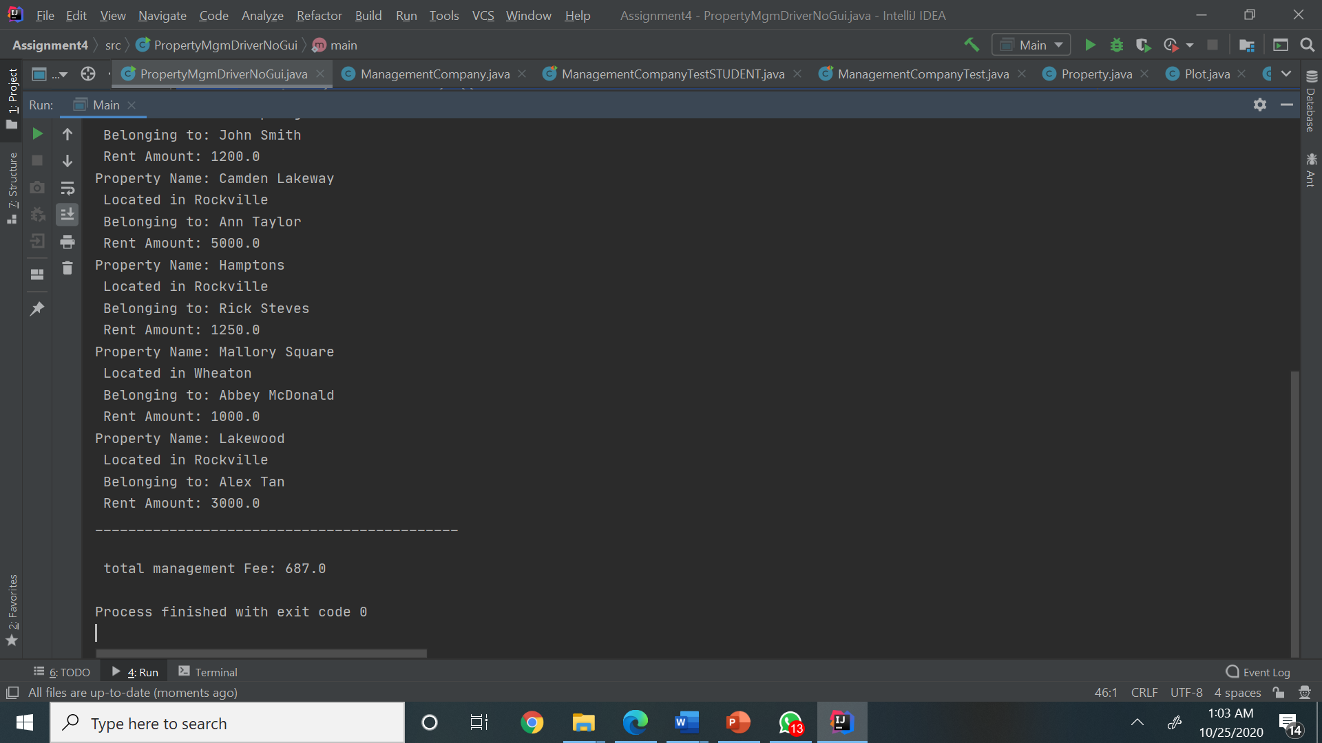

**Lesson Learned:**

This project is the longest and the most difficult that I had to do since I started computer science so far. However, I learned a lot through it. Some of the things that I learned a lot are

1.aggregation: Through this project I learned how useful and powerful aggregation between classes can be.

2. array of object: For some reason, working with the array of property specially the addProperty methods was the hardest part for me in this project. Therefore, to get it done, I had to do some research and learned many things on array of objects through that.

3. Junit test: this is the second Junit test that I have written in my life. I was not that hard compared to the other part of the project, but I still learned a lot.

-The thing that I struggled the most in this project was the addProperties, the overlap and encompasses method. I was excepting to struggle with those methods, so I was not really surprised since I was already warned by the professor in class. Regarding to my next project, the things that I will not probably do differently is to use the divide and conquer method. While writing this project, I looked at it as a whole and it made me feel overwhelmed. Therefore, in my next project I will try to go through it step by step to avoid the feeling of being overwhelmed.

Except those 3 properties I believe that I have perfectly succeed to all the other parts of this project which were mainly basics.